Photo Editor

Everything you need to create and enhance photos to make them even more amazing.
The Photo Editor is a complete photo editing tool in MediaStove, within the image library to create any type of edits to your photos. Simple edit the photo – save it and add it to your website in an instant all within MediaStove.

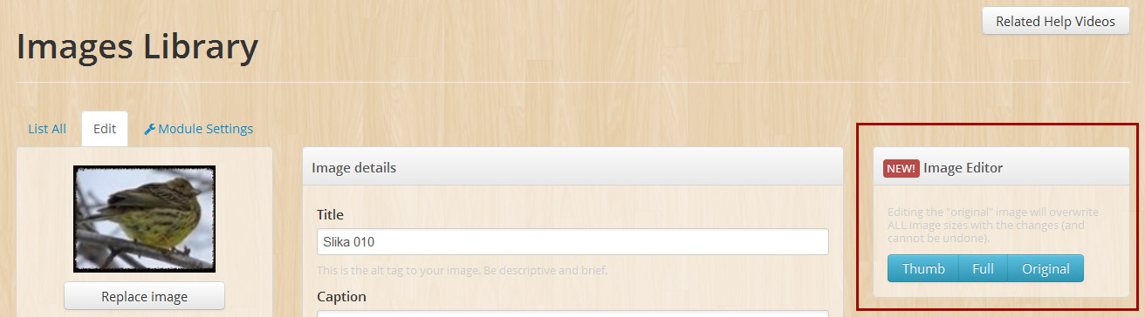
Photo editing features  19 different effects to an image – save out the image and use it directly on your website. | 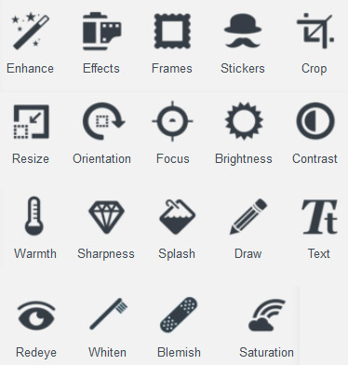
  Enhance  Effects  Frames  Stickers  Crop  Resize  Orientation | Focus  Brightness  Contrast  Warmth  Sharpness  Splash  Draw | Text  Redeye  Whiten  Blemish  Saturation

Enhance  Choose from three preset enhancement options to improve photos with one tap. Hi-Def intelligently sharpens and defines; Illuminate fixes poor lighting issues; and Color Fix performs amazing color correction. |  | 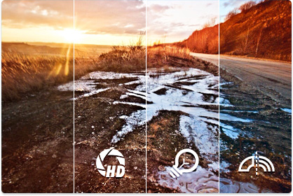
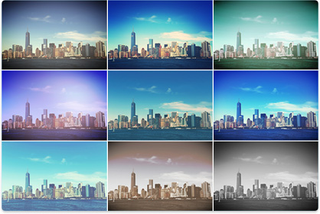 |  |  |  | Effects  Quickly achieve professional results with Photo Editor full line of stunning photo filters, designed to easily enhance and stylize everyday photography.
Frames & Stickers  Boost creativity with imaginative and design-forward frames and stickers. | 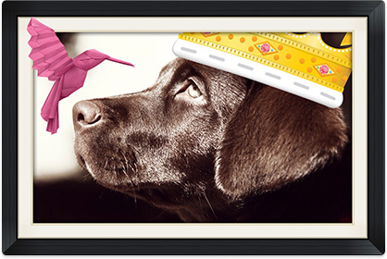
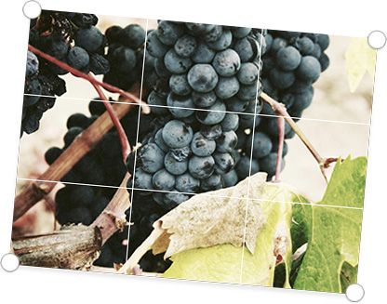 |  |  |  |  | Crop, Resize & Rotate  Quickly reframe, resize and rotate photo with intuitive tools and preset image cropping options (yes, including squares!).
Adjustments  Modify brightness, contrast, saturation, warmth and sharpness with our handy adjust tool. |  |  | 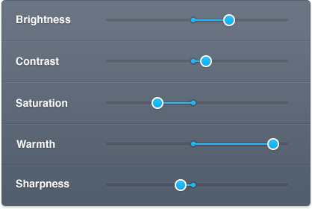
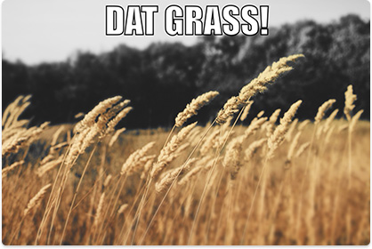 |  |  |  |  |  | Focus, Splash & Meme  Create a meme, selectively add or subtract color and change the focus of images (“tilt-shift”) with our Meme, Splash, and Focus tools.
Draw & Text  Mark up or doodle on photos before sharing them with intuitive Draw and Text tools. Preset colors help you make your point, fast. |  | 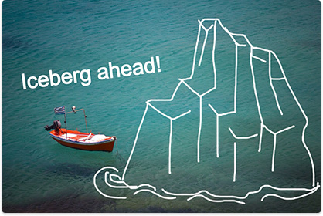
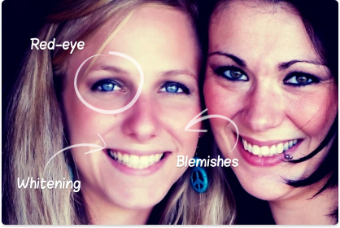 |  | Cosmetic Tools  Remove red eye, whiten teeth, and magically remove blemishes with our convenient set of cosmetic tools.

